**DAILY ONLINE ACTIVITIES SUMMARY**

|  |  |  |  |  |  |  |  |  |
| --- | --- | --- | --- | --- | --- | --- | --- | --- |
| **Date:** | **04/08/2020** | | | | | **Name:** | **V ANJANA PAI** | |
| **Sem & Sec** | **IV sem & B section** | | | | | **USN:** | **4AL18CS094** | |
| **Online Test Summary** | | | | | | | | |
| **Subject** | | **-** | | | | | | |
| **Max. Marks** | | **30** | | **Score** | | | **-** | |
| **Certification Course Summary** | | | | | | | | |
| **Course** | **Programming for Everybody (Getting Started with Python)** | | | | | | | |
| **Certificate Provider** | | | **Coursera** | | **Duration** | | | **19 hours** |
| **Coding Challenges** | | | | | | | | |
| **Problem Statement1: --------------** | | | | | | | | |
| **Status: --------** | | | | | | | | |
| **Uploaded the report in Github** | | | | | **---------------** | | | |
| **If yes Repository name** | | | | | **---------------** | | | |
| **Uploaded the report in slack** | | | | | **YES** | | | |

**Online Test Summary: No internals conducted today.**

**Online Certification Course Summary: Today I learnt about why the program is important.**

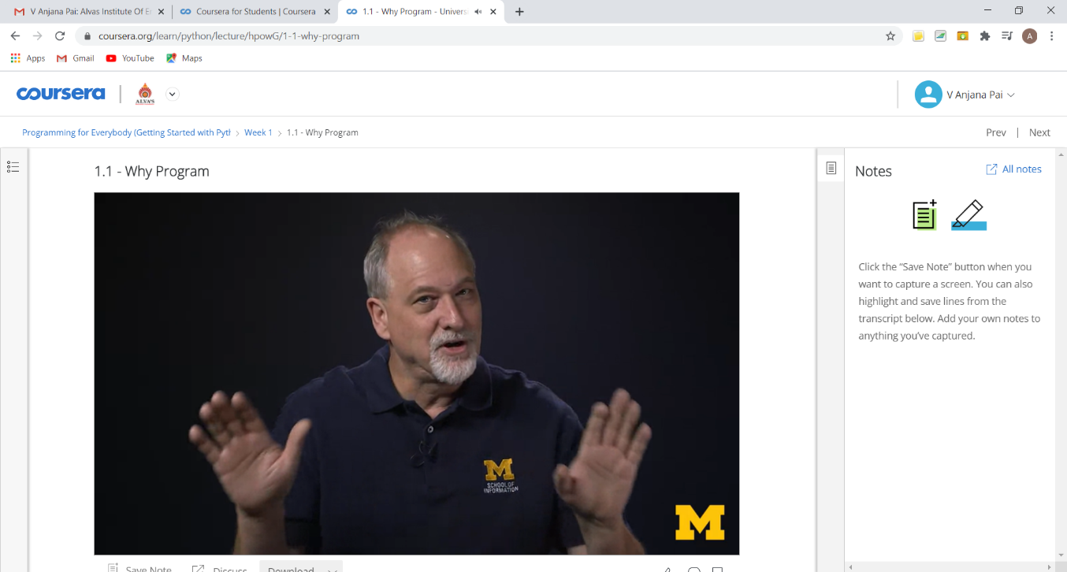

**This is the snapshot of Certificate of Completion.**

**Online Coding Summary: No problem statements were given.**